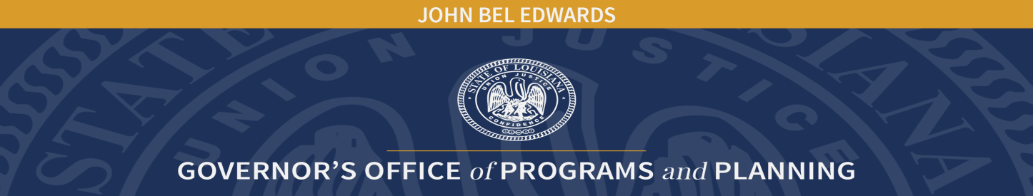
Children’s Cabinet Advisory Board Meeting
Unapproved Minutes
June 28, 2022
Member Name: Attendees
R. Renee Antoine
Charles Coleman, M.D.
Gina Eubanks
Teresa Falgoust
Annette Fruge
Julie Foster Hagan
Angela Harris
Sarah Hinshaw-Fusilier
Rhenda H. Hodnett
Shavana Howard
Tamara Jones
Mattilyn Karst
Susan East Nelson
Kathleen Stewart Richey
Lakisha W. Robinson
Ernise Singleton
Libbie Sonnier
Stephanie Sterling
Karen Stubbs
Alishia R. Vallien
Michael Victorian
Kahree Wahid
Gina B. Womack
Lenell Young

Representatives present for Board Members (Note: They do not count toward quorum and cannot vote):
Kristin Beatty for Jill E. Roshto

Staff:
Dr. Melanie Washington, Children’s Cabinet Executive Director
Michele M. Rabalais, Children’s Cabinet Executive Assistant
Justin Standifer, Children’s Cabinet/Children & Youth Planning Boards, Program Manager

Guests/Presenters:
Levar Robinson, Fathers on a Mission (F.O.A.M.)
Margaret Read, No Kid Hungry
Kelleen Zubick, Healthy Families Produce Rx

Welcome and Call to Order:
Susan East Nelson, Children’s Cabinet Advisory Board (CCAB) Chair, called the meeting to order at 10:08 a.m. and welcomed all present.

Dr. Melanie Washington introduced Tamara R. Jones, the new Children’s Trust Fund Executive Director and Justin Standifer, Children’s Cabinet/Children & Youth Planning Boards, Program Manager.

Roll Call:
Michele M. Rabalais, Executive Assistant, called roll.

Approval of Minutes:
Dr. Charles Coleman made a motion to approve the March 15, 2022 minutes. Lenell Young seconded the motion. All approved. Motion carried.

Fathers on a Mission:
Levar Robinson, Founder and Executive Director, presented information on Fathers On a Mission (F.O.A.M.). F.O.A.M.'s mission is to promote responsible committed fatherhood through education, strong relationships, holistic health, and socioeconomic improvement opportunities to empower fathers, father figures and youth to positively impact and influence communities through monthly fatherhood meetings. F.O.A.M's goal is to support fathers to become self-aware and self-sufficient in supporting their families. Discussion followed.

No Kid Hungry – Healthy Families Produce Rx Program:
Margaret Read, Senior Manager, No Kid Hungry presented an update on the No Kid Hungry program.

No Kid Hungry is a national campaign run by Share Our Strength, a nonprofit working to end the issue of childhood hunger in the United States and around the world.

Since 2010, No Kid Hungry has been working in Louisiana, where its initial focus was on increasing access to nutrition programs for children in New Orleans. Since that time, No Kid Hungry Louisiana has expanded its efforts statewide. Staff collaborates with the Governor’s Office and the Children’s Cabinet to educate and engage school leaders, promote grant opportunities, and raise awareness about the positive impacts that school breakfast and afterschool and summer meal programs provide to kids in need. Discussion followed.

Kelleen Zubick, presented information about the Healthy Families Produce Rx project. This is a USDA funded pilot program connecting low-income families in Louisiana with fresh produce through voucher prescriptions. Currently this program operates in six (6) parishes: Washington, Tangipahoa, St. Helena, St. Landry, Acadia, and Lafayette.

In addition to receiving vouchers for fresh fruits and vegetables, participants are also able to participate in healthy cooking and nutrition classes available in person as well as on-line through the LSU Ag Center. Discussion followed.

Legislative Updates:
Susan East Nelson, CCAB Chair, presented information about bills affecting children and families. Ms. Nelson informed CCAB Members that the legislature had 1,582 bills and 718 study requests. A list of bills will be distributed to CCAB Members. Discussion followed.

Budget Recommendation Discussion:
Dr. Washington, Children’s Cabinet Executive Director, informed CCAB Members that CCAB budget recommendations for the Children’s Cabinet need to be turned in by August 30, 2022. It is of the utmost importance that subcommittees meet and come up with recommendations as soon as possible. Specific budget items need to be turned in to the Children’s Cabinet by November 30, 2022.

Acknowledgement of Public and Public Comments:
None
Adjourn: Kahree Wahid made a motion to adjourn. Alishia R. Vallien seconded the motion. All approved. Meeting adjourned.

